**B.M.S COLLEGE OF ENGINEERING**

(Autonomous College under VTU)

**Department of Electronics and Communication Engineering**

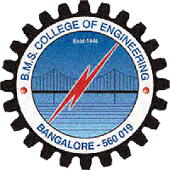

**CERTIFICATE**

This is to certify that the project entitled **“PRECISION AGRICULTURE”** is a bonafide work carried out by **KAVEEN KUMAR M K** (USN:**1BM11EC408**) in partial fulfillment for the award of Bachelor of Engineering degree by VTU Belgaum, during the academic year **2013-2014.**

**Harish V Mekali** **Dr.D .Seshachalam** **Dr.K.Mallikharjuna Babu**

Assistant Prof., ECE, BMSCE HOD, ECE, BMSCE Principal, BMSCE

**External Examination:**  **Signature with date:**

1.

2.